7. Testing and Validation

Testing and validation are indispensable phases in the lifecycle of software development, serving as gatekeepers to ensure the integrity and effectiveness of digital solutions. In the context of our project, the significance of testing and validation is paramount. As we embark on the journey to create an AI-driven system tailored to the unique needs of UPSC aspirants, meticulous testing processes become imperative to guarantee the reliability, accuracy, and relevance of the generated mock interview questions. This chapter delves into our rigorous approach to testing, encompassing diverse methodologies, comprehensive test cases, and meticulous validation procedures, all aimed at delivering a robust and dependable solution for UPSC exam preparation.

The testing and validation phase of our project adhered to a structured approach, ensuring comprehensive coverage and rigorous evaluation. Clear test objectives and criteria were defined to guide testing efforts, while detailed test cases were developed to cover various scenarios and inputs. Utilizing automated testing tools and frameworks streamlined the testing process, enhancing efficiency and accuracy. Test cases were systematically executed across different environments, and results were meticulously documented and analysed. Continuous iteration of testing processes, prompt defect resolution, and performance monitoring were integral to maintaining quality and reliability throughout the project lifecycle.

**7.1 Type of Testing**

In the context of our project, testing and validation played a crucial role in ensuring the accuracy, reliability, and effectiveness of the generated questions. This section focuses on the methodologies and processes employed to validate the functionality and performance of the AI-driven question generation system.

**Type of Testing:**

1. **Unit Testing:**

Individual components and modules of the system were examined to validate their functionality in isolation.

1. **Integration Testing:**

The interaction and interoperability of integrated components were verified to ensure they functioned as intended.

1. **Functional Testing:**

The system was evaluated against functional requirements to verify that it met specified criteria.

1. **Regression Testing:**

The system was repeatedly tested to ensure that recent changes had not adversely affected previously functioning features.

1. **User Acceptance Testing (UAT):**

End-users were involved to validate whether the system met their requirements and expectations.

1. **Performance Testing:**

The system's responsiveness, scalability, and stability were assessed under various load conditions.

**7.2 Test cases & Test Results**

1. **Prompt-Response Alignment:**

Various prompts related to UPSC topics were provided, and the accuracy and relevance of generated responses were validated.

1. **Quality Assessment:**

The quality of generated questions was evaluated based on factors such as relevance, clarity, grammatical correctness, and alignment with UPSC exam standards.

**Test Case ID:** TC_A01

**Test Case Objective:** To check prompt response alignment.

**Prerequisite:** Efficient prompt must be prewritten with contextual input.

**Steps:**

1. **Set Input Data:** Define hobby input as "playing cricket".
2. **Run System:** Execute the system with the provided prompt and input.
3. **Check Output Format:** Validate output follows JSON format with "question", "approach", and "apt_answer" keys.
4. **Compare Outputs:** Verify actual output matches expected JSON format.
5. **Rectify Errors:** Address syntax errors if present, ensuring JSON compliance.
6. **Re-test:** Rerun the test to confirm alignment with expected output.
7. **Confirm Status:** Mark test as “Passed” upon successful output validation, else mark it as “Failed” upon failure of output validation.
8. **Document Results:** Record actual output and any encountered issues for reference.

**Input Data:** hobby => ‘playing cricket’

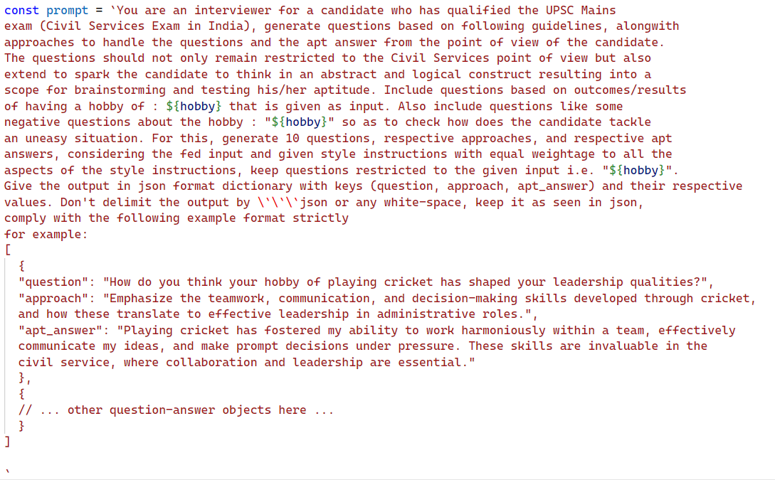**Prompt:**

**Expected Output:**

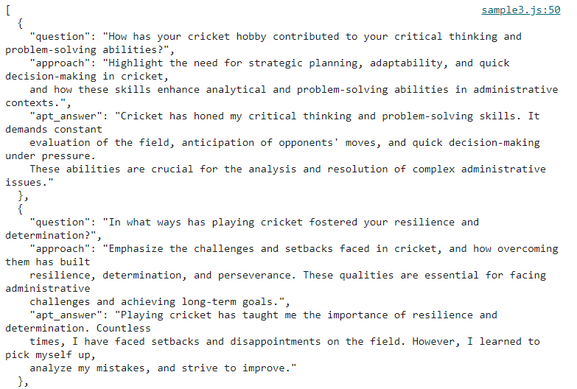

**Actual Output:**



**Status:** Failed

**Test Case ID:** TC_A02

**Test Case Objective:** To check prompt response alignment.

**Prerequisite:** Efficient prompt must be prewritten with contextual input.

**Steps:**

1. **Set Input Data:** Define hobby input as "playing cricket".
2. **Run System:** Execute the system with the provided prompt and input.
3. **Check Output Format:** Validate output follows JSON format with "question", "approach", and "apt_answer" keys.
4. **Compare Outputs:** Verify actual output matches expected JSON format.
5. **Rectify Errors:** Address syntax errors if present, ensuring JSON compliance.
6. **Re-test:** Rerun the test to confirm alignment with expected output.
7. **Confirm Status:** Mark test as "Passed" upon successful output validation.
8. **Document Results:** Record actual output and any encountered issues for reference.

**Input Data:** hobby => ‘playing cricket’

**Prompt:**



**Expected Output:**



**Actual Output:**

**Status:** Passed.

**Test Case ID:** TC_B01

**Test Case Objective:** To assess the quality of generated questions based on relevance, clarity, grammatical correctness, and alignment with UPSC exam standards.

**Prerequisite:** A set of generated questions by the system.

**Steps:**

1. **Collect Generated Questions:** Gather a sample of questions generated by the system.
2. **Evaluate Relevance:** Assess the relevance of each question to UPSC exam topics and themes.
3. **Assess Clarity:** Determine the clarity of each question in conveying its intended meaning.
4. **Check Grammatical Correctness:** Verify the grammatical correctness of each question, ensuring proper syntax and structure.
5. **Evaluate Alignment with UPSC Standards:** Assess the alignment of each question with the format, style, and content expectations of UPSC exam questions.
6. **Document Assessment Results:** Record the evaluation of each question based on relevance, clarity, grammatical correctness, and alignment with UPSC standards.
7. **Identify Quality Issues:** Flag any questions that exhibit deficiencies in relevance, clarity, grammatical correctness, or alignment with UPSC standards.
8. **Provide Feedback and Recommendations:** Offer feedback and recommendations for improving question quality, addressing any identified issues.
9. **Iterative Improvement:** Iterate on question generation algorithms and processes based on assessment results to enhance the overall quality of generated questions.

**Input Data:** hobby => ‘playing cricket’

**Prompt:**

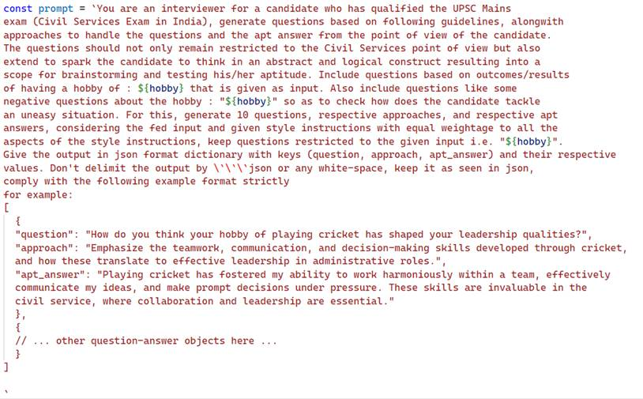

**Expected Output:**

|  |  |  |  |  |
| --- | --- | --- | --- | --- |
| **Parameter** | **Relevance** | **Clarity** | **Grammatical Correctness** | **Alignment with Standards** |
| **Outcome** | **✔** | **✔** | **✔** | **✔** |

**Actual Output:**

|  |  |  |  |  |
| --- | --- | --- | --- | --- |
| **Parameter** | **Relevance** | **Clarity** | **Grammatical Correctness** | **Alignment with Standards** |
| **Outcome** | **✔** | **✔** | **✔** | **✔** |

**Status:** Passed